**Assignment-1:** Create an infographic illustrating the Test-Driven Development (TDD) process. Highlight steps like writing tests before code, benefits such as bug reduction, and how it fosters software reliability.

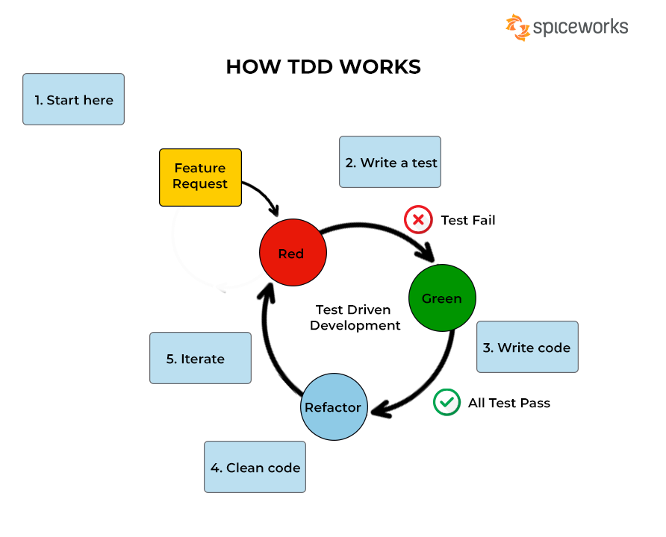

* The test cases will be written first according to the requirement.
* At first it will be red because the code was not written yet.
* Then the code will be written to the test cases.
* If the test case to the code passes it will turn green.
* If the test case failed the code will be checked and changed.
* Here we perform unit testing.

**Advantages of TDD:**

* Faster debugging
* Less bugs
* The code will be written to test cases.
* Modularity
* Improves the quality of software.